Part Number: PZQ44-42100

Kit Contents
Item # | Quantity Reqd. | Description
1 | 1 | LH Step Assembly
2 | 1 | RH Step Assembly
3 | 2 | Rear Mount
4 | 2 | Front Mount Channel
5 | 1 | RH Front Mount Jack Plate
6 | 1 | LH Front Mount Jack Plate
Hardware Bag Contents
Item # | Quantity Reqd. | Description
7 | 4 | M10 Stud Plate
8 | 4 | M10 Flat Washer
9 | 4 | M10 Spring Washer
10 | 4 | M10 Nut
11 | 8 | M6 SEMS Bolt
12 | 8 | M6 Flanged Nut
13 | 2 | M8 U Bolt
14 | 4 | M8 Spring Washer
15 | 4 | M8 Washer
16 | 4 | M8 Nut
17 | 10 | M8 SEMS Bolt
18 | 2 | M8 Washer, Clipped
19 | 2 | M8 Flanged Nut
20 | 1 | U-bolt Card
21 | 1 | Jack Label
Additional Items Required For Installation
Item # | Quantity Reqd. | Description
1
2
3
Conflicts
General Applicability
Recommended Sequence of Application
Item # | Accessory
1
2
3
*Mandatory
Vehicle Service Parts (may be required for reassembly)
Item # | Quantity Reqd. | Description
1
2
3
Recommended Tools
Personal & Vehicle Protection | Notes
Safety Glasses
Special Tools | Notes
None
Installation Tools | Notes
Trim Removal Tool
Putty Knife or Scraper
Screwdriver | Large Flat Blade
Ratchet
Sockets | 10mm, 13mm, 17mm
Extension | Short
Wrench | 10mm, 13mm, 17mm
Hammer
Center Punch
Drill & Drill Bit | 6.5mm
Deburr Tool
Torque Wrench | 0 to 50 N-m (37 ft-lbf)
Special Chemicals | Notes
Rust Prohibitor | 3M Ultra Underbody Sealant
Legend
STOP: Damage to the vehicle may occur. Do not proceed until process has been complied with.
OPERATOR SAFETY: Use caution to avoid risk of injury.
CAUTION: A process that must be carefully observed in order to reduce the risk of damage to the accessory/vehicle and to ensure a quality installation.
TOOLS & EQUIPMENT: Used in Figures calls out the specific tools and equipment recommended for this process.
REVISION MARK: This mark highlights a change in installation with respect to previous issue.
SAFETY TORQUE: This mark indicates that torque is related to safety.

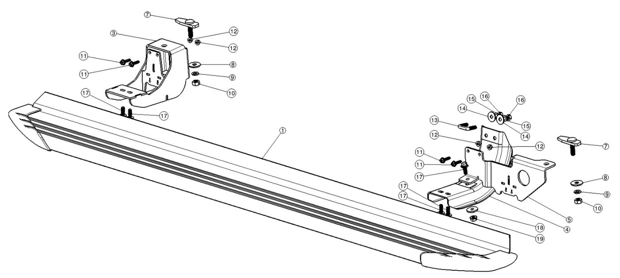
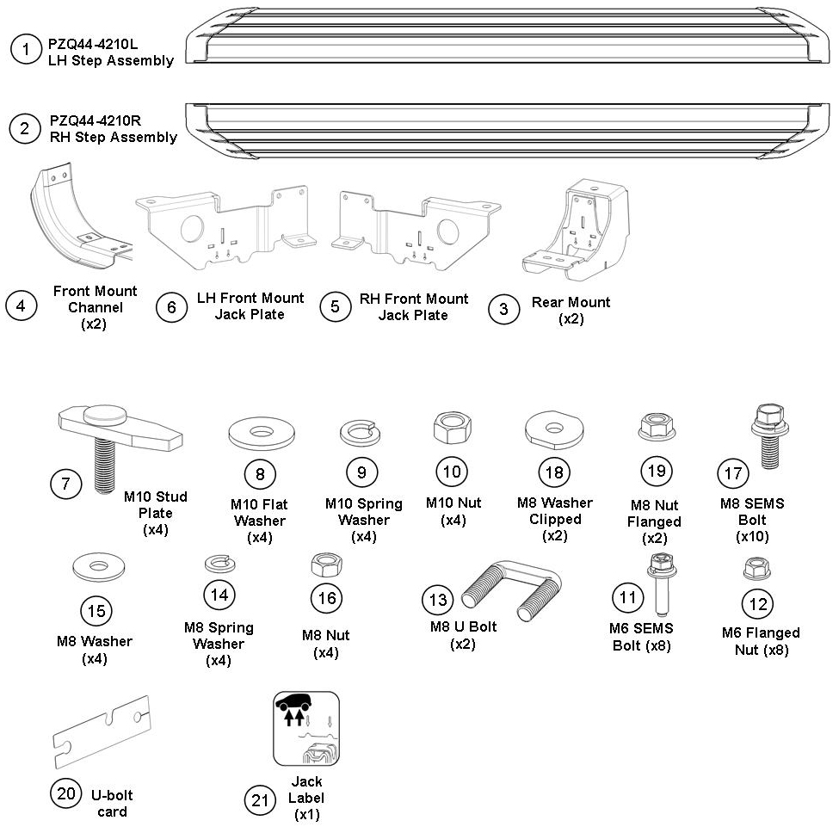
RHS side step exploded assembly
LHS assembly symmetrically opposite
General Notes

- Place these instructions in vehicle’s glove box after installation is complete.
- Please read these instructions carefully before installation, paying special attention to all Notice & Caution notes.
- Failure to do so may result in damaged parts or injury to the installer or customer.
- It is recommended that this accessory is fitted only by a qualified Lexus technician.
- Ensure all recyclable discarded vehicle or accessory components and packaging are recycled following local recycling regulations.

General Vehicle and Accessory Warranty Notes and Cautions

- Do not fit this Side Step to any other vehicle.
- Do not repair or modify the Side Step or its mounting hardware in any way - repair or modification can result in non-compliance with Regulatory Requirements and may effect proper operation of the airbag resulting in serious injury.
- Do not remove the label from the Side Step.
- Do not modify the vehicle in any way other than the manner specified in these fitting instructions. To do so may void the warranty.

General Vehicle Notes and Cautions

- If damage or concerns are identified that may interfere with the installation of the accessory, or affect the function or safety of the vehicle, inform the customer prior to proceeding with the installation.
- Ensure special care is taken and the applicable repair manual is followed to prevent any damage to the vehicle.
- Protect and safely store any vehicle components removed.

General Accessory Notes and Cautions

- It is advisable to seek assistance from another person when lifting heavy components
- This accessory is only to be fitted to the vehicles listed on the front of this manual, do not use this product for any make or model not listed as it may render the vehicle unsafe to operate.
- Fit the accessory only using the method outlined in these instructions, do not fit the accessory by any other method or attachment points.

Side Step Care Procedures

- Daily Exposure to pollution in the air, road grime and corrosive environments such as sea side roads can affect the appearance and finish of the accessory.
- Regularly wash the accessory using a reputable automotive wash detergent, rinse with fresh water and chamois dry.

WARNING!

- Do Not Use Harsh Chemicals, industrial Cleaners or solvents.
- Do Not use abrasive compounds or abrasive cleaning tools
- Use reputable cleaning products only, as recommended by the manufacturer.

Care must be taken when installing this accessory to ensure damage does not occur to the vehicle. The installation of this accessory should follow approved guidelines to ensure a quality installation.

These guidelines can be found in the "Accessory Installation Practices" document.

This document covers such items as:-
- Vehicle Protection (use of covers and blankets, cleaning chemicals, etc.).
- Safety (eye protection, rechecking torque procedure, etc.).
- Vehicle Disassembly/Reassembly (panel removal, part storage, etc.).
- Electrical Component Disassembly/Reassembly (battery disconnection, connector removal, etc.).

Please see your Lexus dealer for a copy of this document.

Prepare the Vehicle.
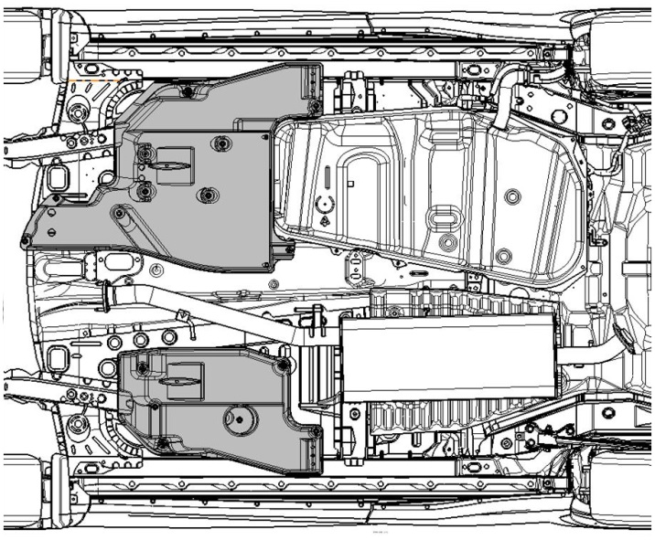
  - Remove the front passenger’s side under cover as per the vehicle service manual (Fig. 1-1). Keep all parts for reinstallation.
Fig. 1-1
Remove
Front
10 mm socket & ratchet
    - Remove the 3 push clips.
    - Remove the 3 captive plastic nuts.
  - Remove the front driver’s side under cover as per the vehicle service manual (Fig. 1-1). Keep all parts for reinstallation.
    - Remove the 6 push clips.
    - Remove the captive plastic nut.
    - Remove the bolt.
    - Remove the 2 nuts with captive washers.
  - Remove the body sealer from the passenger’s side of the vehicle.
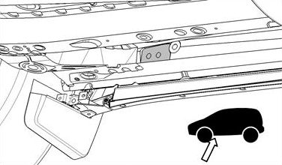
    - Locate the two holes on the inner side rail (Fig. 1-2).
Fig. 1-2

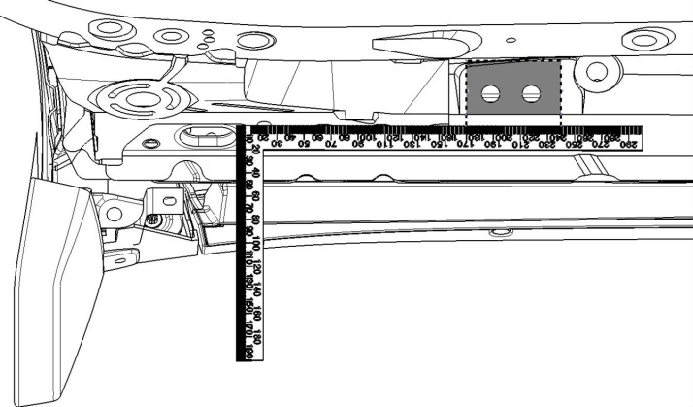
    - Measure an area from 170mm to 240mm back from the elongated hole, and remove all the body sealer from this area (Fig. 1-3).
Fig. 1-3
Putty knife
170mm
240mm
Remove body sealer
    - Repair any damaged paintwork and cover the panel edges with anti-rust sealant.
  - Repeat Step 1(c) for the driver’s side of the vehicle.

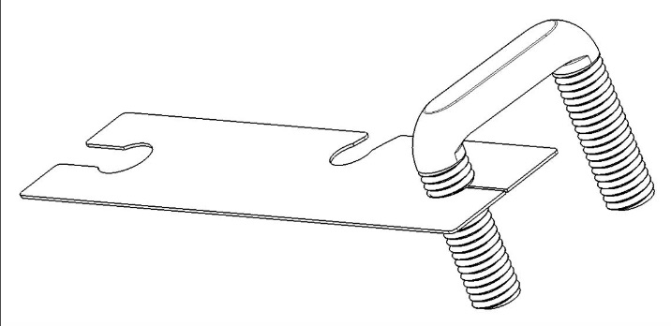
Install the Passenger’s Side Running Board.
Fig. 2-1
  - Install a U-bolt.
    - Feed the U-bolt card onto one leg of a M8 U-bolt (Fig. 2-1).

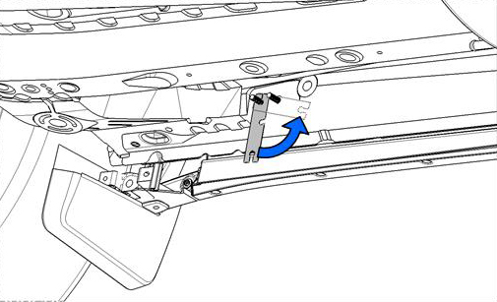
    - Feed the open leg of the M8 U-bolt through the front of the two holes.
Fig. 2-2
    - Feed the same leg of the U-bolt back out through the second rearward hole (Fig. 2-2).
    - Rotate the U-bolt card around until the second slot in the U-bolt card engages the thread to hold the U-bolt in position (Fig. 2-2).

  - Install the front mount channel.
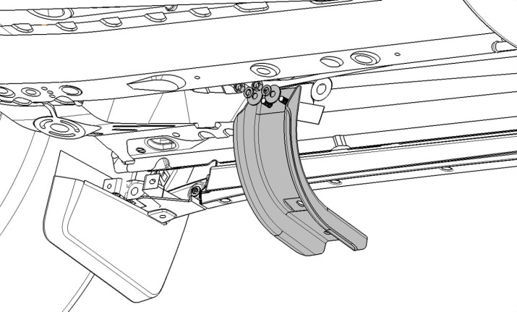
    - Leave the U-bolt card in place and align the front mount channel section over the M8 U-bolt (Fig. 2-3).
Fig. 2-3
13mm socket & ratchet

    - Place an M8 washer, spring washer, and M8 nut onto each leg of the U-bolt. Do not tighten (Fig. 2-3).
    - Remove the U-bolt card from beneath the channel section, and then hand tighten the M8 nuts to retain the channel in place.
  - Install the front stud plate.
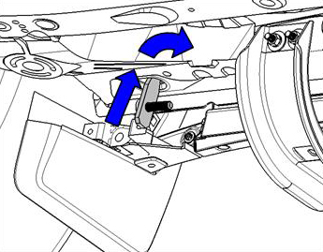
    - Insert an M10 stud plate up through the elongated hole (Fig. 2-4).
Fig. 2-4
NOTE: If rubber grommets are in place, remove and discard them.

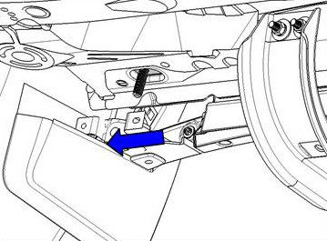
    - Insert the long side of the plate first and rotate it towards the rear of the vehicle, then slide it forward when the plate is fully inside the side rail (Fig. 2-5).
Fig. 2-5
Sill flange
NOTE: Check the sill flange for damage. If it is not straight, use pliers to straighten it (Fig. 2-5).

  - Pre-install the front mount jack plate.
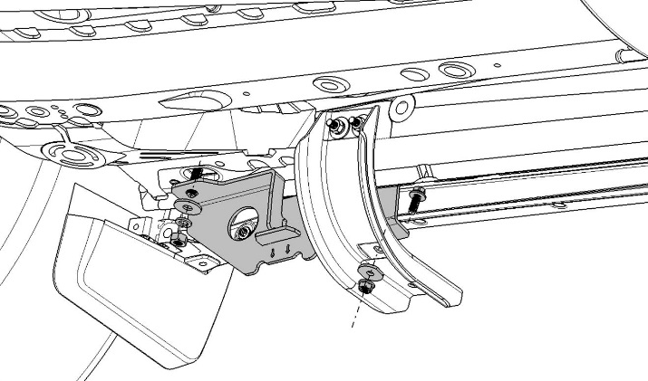
    - Position the front mount jack plate over the front mount channel and ensure the stud plate bolt is through the hole in the jack plate (Fig. 2-6).
Fig. 2-6
17mm socket & torque wrench
    - Place an M10 washer, spring washer and nut onto the thread (Fig. 2-6).
NOTE: The jack plate straddles the sill flange, on the inside at the front and on the outside at the channel section.
    - Align the hole at the rear of the jack plate with the hole in the channel section (Fig. 2-6).
    - Attach the front mount jack plate and channel section together using an M8 SEMS bolt, clipped washer and M8 flange nut (Fig. 2-6).
Torque: M10 nut – 44 N-m (33 ft-lbs)
    - Hand tighten the M8 nut, ensuring the jack plate sits against the sill flange.
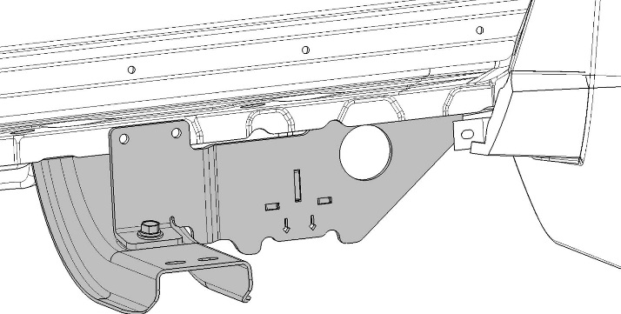
    - Use a center punch to mark the sill flange through the two holes in the jack plate (Fig. 2-7).
Fig. 2-7
Center punch & hammer
Mark here
  - Install the front mount jack plate.
    - Remove the nuts, washers and bolts from Steps 2(d)(4) & 2(d)(5) and remove the jack plate.
    - Drill the marked positions on the sill flange using a 6.5mm drill bit.
    - Deburr and apply sealant to the holes.

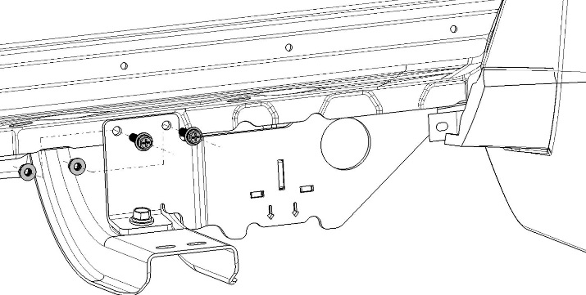
    - Reinstall the jack plate as described in Step 2(d) (Fig. 2-8).
Fig. 2-8
10mm, 13mm & 17mm sockets; torque wrench

    - Install two M6 SEMS bolts and flange nuts through the jack plate and sill flange (Fig. 2-8).
Torque: 9 N-m (80 in-lbs)
    - Torque the M8 SEMS & U-bolt nuts to spec.
Torque: 24 N-m (18 ft-lbs)
WARNING: The U-bolt must be tightened evenly, otherwise the vehicle and/or part may be damaged.
    - Torque the M10 weld stud nut to spec.
Torque: 44 N-m (33 ft-lbs)

  - Install the rear stud plate.
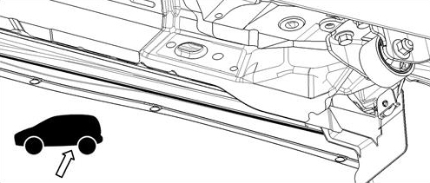
    - Remove the plug from the rear tie down point (if applicable, Fig. 2-9).
Fig. 2-9

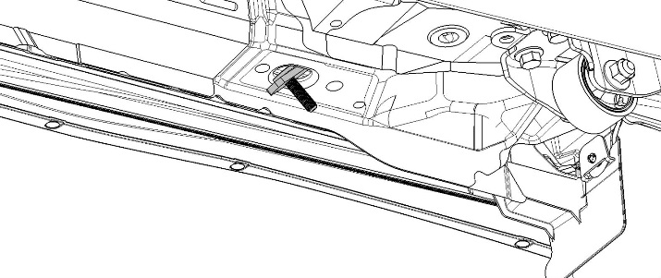
    - Insert an M10 stud plate up through the hole (Fig. 2-10).
Fig. 2-10

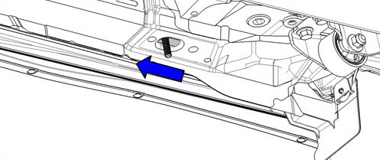
    - Insert the long side of the plate first and rotate it towards the rear of the vehicle, then slide it forward when the plate is fully inside the side rail (Fig. 2-11).
Fig. 2-11
Front

  - Pre-install the rear mount.
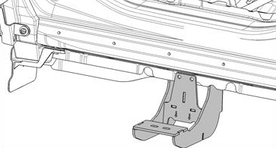
    - Ensure that the attachment plate is on the outside of the sill flange and position the rear mount over the stud plate (Fig. 2-12).
Fig. 2-12

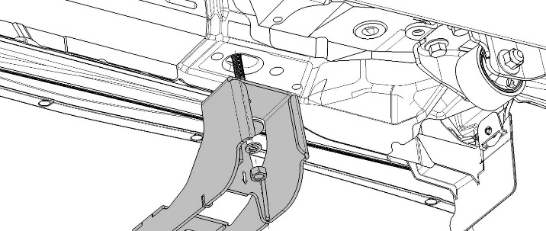
    - Use an M10 washer, spring washer and M10 nut to attach the rear mount to the vehicle (Fig. 2-13). Hand tighten only.
Fig. 2-13
17mm socket & ratchet

NOTE: For ease of installation, the large hole in the U-bolt card may be used to hold the two washers in place while locating the nut onto the thread.
  - Pre-install the running board.
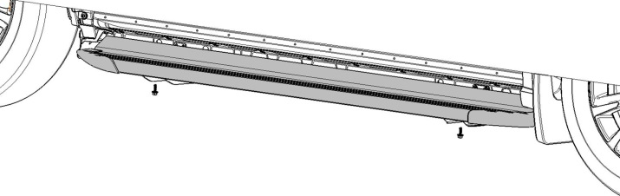
    - Ensure that the passenger’s side running board is used and position the it onto the mounts (Fig. 2-14).
Fig. 2-14
13mm socket & ratchet

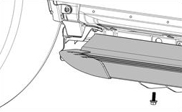
NOTE: The cut off corner of the return on the step goes to the rear (Fig. 2-15).
Fig. 2-15

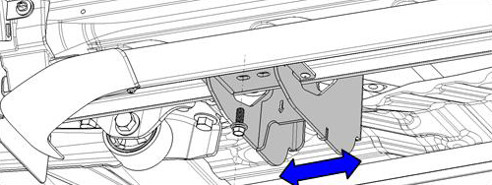
    - Fit the step to the mount using two of the M8 SEMS bolts on each mount. Hand tighten only (Fig. 2-16).
Fig. 2-16
13mm socket & ratchet

NOTE: The rear mount assembly may need to be adjusted along the length to achieve a good fit. Aim to have the SEMS bolts centered on the slotted holes in the mounts and the rear mount should be against the sill flange (Fig. 2-16).
    - Once the bracket and running board are aligned, tighten the rear mount to remove any slack or movement. This will prevent the bracket from moving in the following steps.
  - Install the rear mount.
    - Remove the step from the mounts.
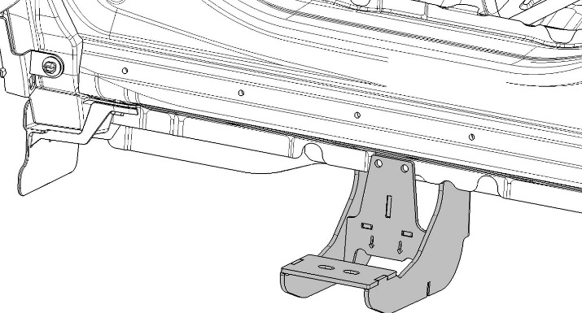
    - Use a center punch to mark the sill flange through the holes in the rear mount (Fig. 2-17).
Fig. 2-17
Center punch & hammer
Mark here
    - Remove the rear mount.
    - Drill the marked positions on the sill flange using a 6.5mm drill bit.
    - Deburr and apply sealant to the holes.
    - Reinstall the rear mount as described in Step 2(g).
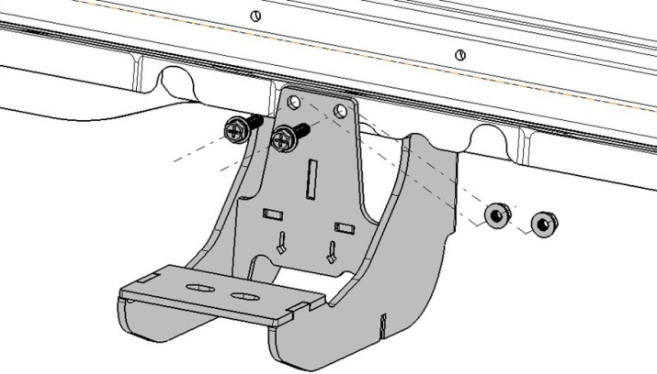
    - Install two M6 SEMS bolts and flange nuts through the rear mount and sill flange (Fig. 2-18).
Fig. 2-18
10mm & 17mm sockets; torque wrench

    - Torque the M6 nuts to spec.
Torque: 9 N-m (80 in-lbs)
    - Torque the M10 weld stud nut to spec.
Torque: 44 N-m (33 ft-lbs)

  - Install the running board.
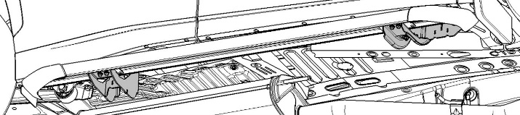
    - Reposition the running board onto the mounts (Fig. 2-19).
Fig. 2-19

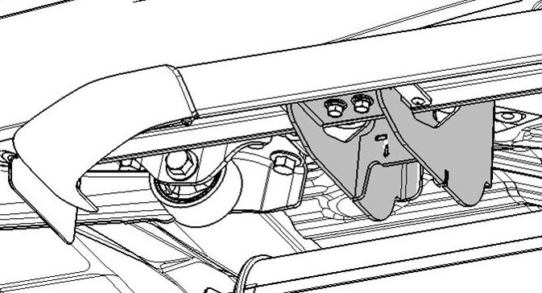
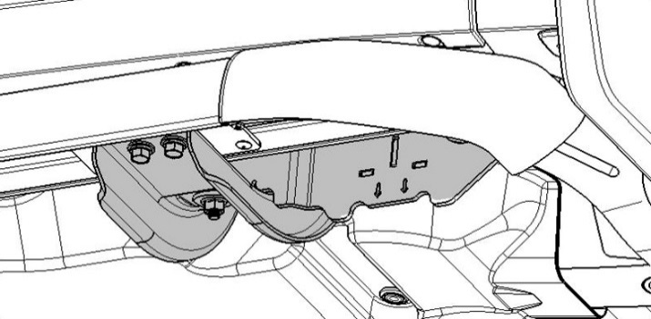
    - Use four M8 SEMS bolts to attach the running board to the mounts (Fig. 2-20 & Fig. 2-21).
Fig. 2-20
13mm socket & torque wrench

Rear
Fig. 2-21
13mm socket & torque wrench

Front
    - Check that the step is level and has a uniform gap to the sill flange (the target gap is 15 mm).
    - Torque the M8 SEMS bolts to spec.
Torque: 24 N-m (18 ft-lbs)

Install the Driver’s Side Running Board.
  - Repeat Step 2 for the driver’s side.

Replace the Under Covers.
  - Reinstall the front passenger’s side under cover as per vehicle service manual (Fig. 4-1).
Fig. 4-1
Replace
Front
10 mm socket & ratchet
    - Replace the 3 push clips.
    - Replace the 3 captive plastic nuts.
  - Reinstall the front driver’s side under cover as per vehicle service manual (Fig. 4-1).
    - Replace the 6 push clips.
    - Replace the captive plastic nut.
    - Replace the bolt.
    - Replace the 2 nuts with captive washers.

Update the Jack Label.
    - Remove the vehicle jack from the vehicle.
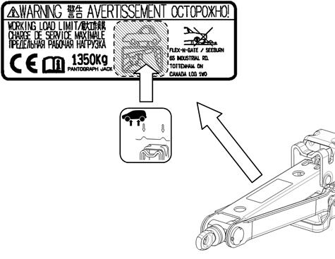
    - Apply the jack label (Fig. 5-1).
Fig. 5-1
    - Replace the jack in the vehicle.

Accessory Function Checks
Step is level
Gap is uniform

Vehicle Function Checks

15mm to the sill flange

Vehicle Appearance Check
After accessory installation and removal of protective cover(s), perform a visual inspection.

Ensure no damage (including scuffs and scratches) was caused during the installation process.
(For PPO installations, refer to TMS Accessory Quality Shipping Standard.)

